**Assignment #1 Data Model Design**

**Design a Normalized Relational Database for “Pets-We-B”**

A retail Pet Store has asked you to design a database to capture the important aspects of their business data. Your task is to use Excel to display a relational database that follows the basic design principles.

**REQUIREMENTS:**

The pet store will need to store **CUSTOMER**data. This data includes the name of the customer (First and Last) and their addresses and phone numbers.

**PET**data is stored as well, including the pet species, the colour, gender, birthdate, price, and an indication of whether the pet is spayed or neutered.

**EMPLOYEE**data includes names, addresses, phone numbers, job/position and hourly pay rate.

Pets-We-B has several retail **LOCATIONS**. You will need to store data on store location, the date the store opened, the type of store (mall, standalone, kiosk, etc.), the name of the store manager, and the store phone number and address.

Finally, **SALES**are stored. Sales data capture the pet being sold, the store at which it was purchased, the employee who conducted the sale, the date and time of the sale, and the customer making the purchase.

**PROCESS:**

Begin by reviewing the requirements for the data above, and then design a system of tables that will allow Pets-We-B to capture *at least* the critical data identified above.

Use Microsoft Excel to create tables:

* The first column should include your field name
* The second column should include a sample value for the field
* The third column should indicate the data type you will use
* Highlight (in yellow) the primary key for each table
* Highlight (in green) any foreign keys in your tables
* lease include all your tables on one worksheet within your Excel workbook.

**SAMPLE TABLE**

* 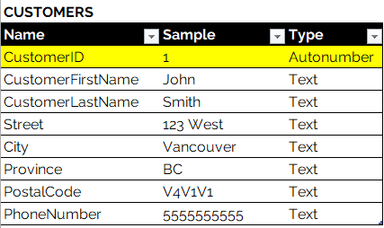

*Please note that this exercise is simply to display the design of a relational data model. You will not be loading this data into the Excel data model.*

**SUBMIT THE FILE TO THE ASSIGNMENT 1 FOLDER IN THE LEARNING HUB.**

Submit your Data Model Assignment 1 in **Excel** format with the name format **PETSA00000000.xlsx** where A00000000 is your Student ID.

**REVIEW THE**[**RUBRIC**](https://learn.bcit.ca/d2l/common/dialogs/quickLink/quickLink.d2l?ou=824553&type=rubric&rCode=BCIT-4384092)**TO ENSURE YOU HAVE MET THE ASSIGNMENT CRITERIA.**

**TIPS FOR SUCCESS:**

* Read the instructions carefully to ensure you capture all the detail required
* Pay careful attention to the granularity of your fields
* Follow best practices when naming your fields carefully

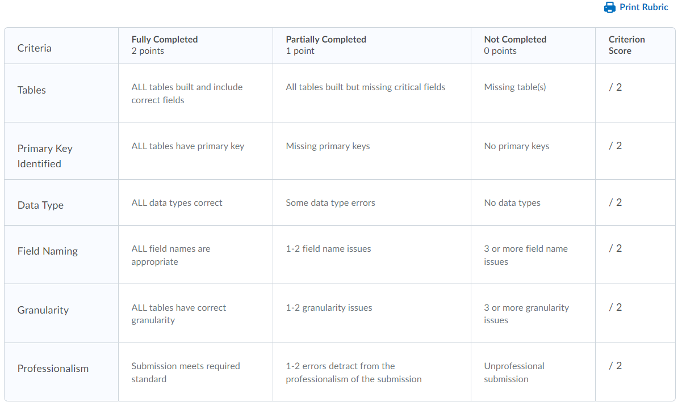

Questions Answered by Shauna

Phone Numbers should be numbers and should be stored as text. You should only store fields as numbers if you will be using the value in a calculation.

You can store phone numbers with or without hyphens.

There is no required sample data length.

I have recreated the tables now. I have a few questions:

1. I remember in the videos on BCIT Open Learning you mentioned that you need the name of the table infront of each record in their table. Is this correct like how I did it in the tables below? Example for CUSTOMER there is CustomerID, CustomerFirstName, CustomerLastName, CustomerStreet etc. This is the best practice.
2. **In the Sales table**you also mentioned a part when it says "the store at which is was purchased" I am assuming you mean you wanted the LocationID to be the foreign key in that Sales table correct? Correct.
3. **In the Sales table**you also mentioned the customer making the purchase. This means you are referring to the CustomerID as the foreign key correct? Correct.
4. When you are referring to things like in EMPLOYEE has an address did you want me to break it down into EmployeeStreet, EmployeeCity, EmployeeProvince, EmployeePostalCode?  This is the best practice.
5. For the **PETS table** for know if the pet is neutered or not is it ok if I put it as PetIsNeutered and make it a boolean?  Yes.
6. When you say you want this information I create in excel are you saying you want each table to be in it's own tab within the same excel document? or just all tables on one page in the excel document? As per the instructions, please include all your tables on one worksheet within your Excel workbook.